Cloudera manager external authentication using open LDAP

First we need to go to cloudera manager console

Administration –users – if we click on add user it will be created internally.

Its not good right..

So that is why LDAP or AD need to be integrated with cloudera manager so that those users will be automatically reflect in cloudera.

This feature is available in enterprise data dub edition or enterprise licenced version

Express edition is not possible to integrate with openldap.

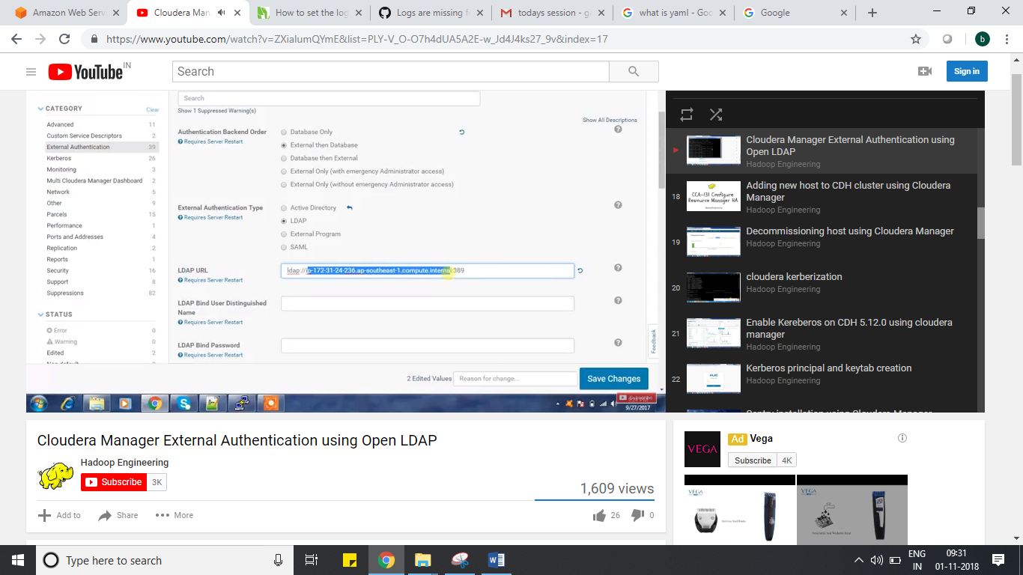

Details:

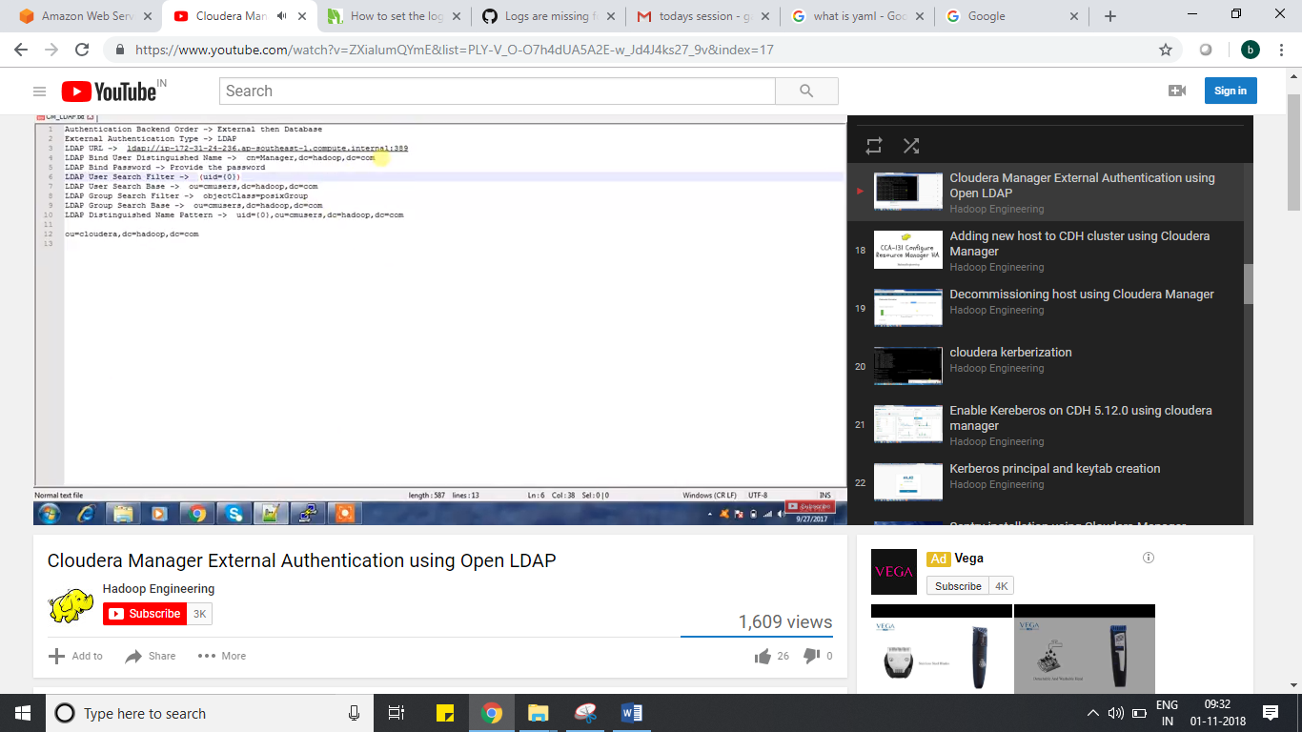

Once you mention all details in cloudera manager web consoler – administraton tab – settings – left side – external authentication – above details..

Save changes

After that it will show restart required.

That means we need to restart the cloudera manager

service cloudera-scm-server restart

after 2 to 3 min connect it.

Whatever users are creted in that OU, with those users u can see u will not be having full permissions.

If that user want full permission, administration tab , users – permissions – full admin permission then he can get full permission.

Screenshsot:

